Ethical Business Statement July 2025

**Context, scope and overview**

1. Wavemar Electronics Ltd (the Company, we, us) is committed to maintaining the highest standards of ethics and integrity and to conducting our business legally, responsibly, ethically, honestly and fairly and we require all our workers to carry out their duties in accordance with these principles.
2. We take a zero-tolerance approach to legal and ethical misconduct, and are committed to acting professionally, fairly and with integrity in all our business dealings and relationships, wherever we operate, and implementing and enforcing effective systems to counter wrongdoing. Our attitude to dishonesty, illegal or improper activity amongst our workers, partners and suppliers is that of zero tolerance.
3. We take our legal and ethical responsibilities very seriously and are committed to preventing the facilitation of any form of legal or ethical misconduct in order to maintain and protect the Company reputation with our clients, suppliers, contractors, workers and all other third parties with whom the Company has dealings or whom may be affected by our activities.
4. We will uphold all laws applicable to us in countering legal and ethical misconduct in all the jurisdictions in which we operate. However, we remain bound by the laws of the UK in respect of our conduct both at home and abroad.
5. In pursuit of these objectives the Company will ensure that our policies, procedures and practices are open, fair and equitable for all parties involved.
6. This policy statement should be read alongside other key company policies. In particular, the Company’s Financial Ethics, Whistleblower, GDPR, Equal Opportunities, Anti- harassment & Bullying, Disciplinary Rules & Procedures and Grievance policies.
7. In this policy statement, third party means any individual or organisation you come into contact with during the course of your work for us, and includes actual and potential clients, customers, suppliers, distributors, business contacts, agents, advisers, and government and public bodies, including their advisors, representatives and officials, politicians and political parties.
8. This policy statement applies to all individuals working at all levels and grades, including senior managers, officers, directors, employees (whether permanent, fixed- term or temporary), consultants, contractors, trainees, seconded staff, homeworkers, casual workers and agency staff, volunteers, interns, agents, sponsors, or any other person associated with us, or any of our subsidiaries or their employees, wherever located (collectively referred to as workers or you in this policy statement).

**KEY PRINCIPLES**

**Trading practices**

1. We will not engage in any business practice which is illegal, unethical or amounts to unfair competition.
2. We will uphold all laws relevant to our business activities in all the jurisdictions in which we operate.
3. We will maintain accurate records of our business transactions as required by law and no record, entry or document shall be deliberately false, distorted, misleading, misdirected, incomplete or suppressed.
4. We will protect confidential information in our possession from unauthorised use or disclosure, including confidential information relating to our workers and any third parties, and comply with all relevant data protection legislation whether held digitally or otherwise. Further details can be found in our GDPR policy.

**Discrimination**

1. We will not discriminate against any worker or third party based on their protected characteristics and will uphold Article 14 of the Human Rights Act 1998 in respect of protection from discrimination. The company makes no discrimination in hiring, compensation, access to training, promotion, termination or retirement based on age, disability, gender, marital status, race, caste, nationality, ethnic or national origin, religion or belief, sexual orientation, any other protected characteristic, union membership or political affiliation. Further details can be found in our Equal Opportunities policy.

**Child and Forced Labour**

1. We will not employ workers under the legal minimum age for work as stipulated by the Employment Act 2008. Nor will children or young persons under 18 be employed at night or in hazardous conditions.

**Working conditions**

1. We will provide a safe and hygienic working environment, bearing in mind the prevailing knowledge of the industry and of specific hazards. Adequate steps shall be taken to prevent accidents and injury to health arising out of, associated with, or occurring in the course of work, by minimising, so far as is reasonably practicable, the causes of hazards inherent in the working environment.
2. Workers shall receive regular and recorded health and safety training, and such training shall be repeated for new or reassigned workers.
3. Access to clean toilet facilities, water, and, if appropriate, sanitary facilities for food storage shall be provided.
4. We will provide a safe and hygienic working environment, bearing in mind the prevailing knowledge of the industry and of specific hazards. Adequate steps shall be taken to prevent accidents and injury to health arising out of, associated with, or occurring in the course of work, by minimising, so far as is reasonably practicable, the causes of hazards inherent in the working environment.
5. We will have a Senior Manager assigned to the responsibly of Health and Safety in the workplace.

**Working Hours**

1. We will adhere to the Working Time Regulations 1998 with opt-out clauses publicised to staff and opt out agreements signed and kept on record. All overtime shall be voluntary. Overtime shall be used responsibly, considering all the following: the extent, frequency and hours worked by individual workers and the workforce. It shall not be used to replace regular employment.

**Remuneration**

1. We will pay wages for standard working hours that meet or exceed national minimum wage or living wage levels as appropriate. We will uphold the requirement of the National Minimum Wage Act 1998. We will pay a fair wage, appropriate in the current market, and review this annually.
2. employment conditions in respect to wages before they enter into employment and  
   All workers shall be provided with written and understandable information about their  
   about the particulars of their wages for the pay period concerned each and every time that they are paid.

**Discipline**

22.We only make charitable donations that are legal and ethical under local laws and practices. No donation must be offered or made without the prior approval of the Managing Director.

**Administration**

1. The Board of Directors shall assume responsibility for Governance and Compliance requirements and the implementation of this policy statement and all Company policies.
2. The Board shall review, on an annual basis, the implementation and effectiveness of this policy statement and shall ensure that workers within the relevant business units are made aware of the Ethical Business Policy statement.
3. All new workers are made aware of the policy statement and given training or guidance on its operation.

**Compliance**

1. The Board places the highest importance on the successful implementation of this policy statement and ongoing compliance with its terms. All workers will be required to read, understand and comply with this policy statement, and to conduct themselves at all times having regard to the very highest standards of ethical conduct and probity. Workers must not only be ethical and honest in fact but must also take reasonable measures so as to not lay themselves open to suspicion of unethical or dishonest conduct.
2. Non-compliance with the policy statement will be deemed to be a breach of the relevant contract of employment or contract with the relevant party. Non-compliance by employees will give rise to disciplinary proceedings which may result in dismissal for gross misconduct. Non-compliance with certain aspects of the policy statement may also give rise to criminal proceedings.
3. All instances of non-compliance with this policy statement should be reported to the Director in charge of Governance and Compliance or Managing Director. All communications will be held in confidence and, if requested, can be on an anonymous basis.
4. Additionally, all workers are encouraged to bring to the Company’s attention areas of weakness that they may have identified in the procedures they use which could allow opportunities for unethical or dishonest conduct and to suggest improvements to these procedures to reduce the possibility of such conduct.

**Record-keeping**

1. All business records relating to dealings with workers and third parties will be prepared and maintained with strict accuracy and completeness.
2. We will maintain appropriate internal controls which will ensure, audit and evidence the keeping of accurate business records.

**How to raise a concern**

1. Workers are encouraged to raise concerns about any issue or suspicion of malpractice at the earliest possible stage. Concerns should be reported by following the procedure set out in our Whistleblowing Policy at section 12.

**Protection**

1. Workers who refuse to act unethically, or those who raise concerns or report another’s wrongdoing, are sometimes worried about possible repercussions. We aim to encourage openness and will support anyone who raises genuine concerns in good faith under this policy statement, even if they turn out to be mistaken.
2. We are committed to ensuring no one suffers any detrimental treatment as a result of refusing to act unethically, or because of reporting in good faith their suspicion that actual or potential unethical conduct has taken place or may take place in the future. Detrimental treatment includes dismissal, disciplinary action, threats or other unfavourable treatment connected with raising a concern.

**Training and communication**

1. Training on this policy statement forms part of the induction process for all new workers. All existing workers will receive regular, relevant training on how to implement and adhere to this policy statement.
2. Our zero-tolerance approach to unethical misconduct must be communicated to all suppliers, contractors and business partners at the outset of our business relationship with them and as appropriate thereafter.

On behalf of Wavemar Electronics Ltd

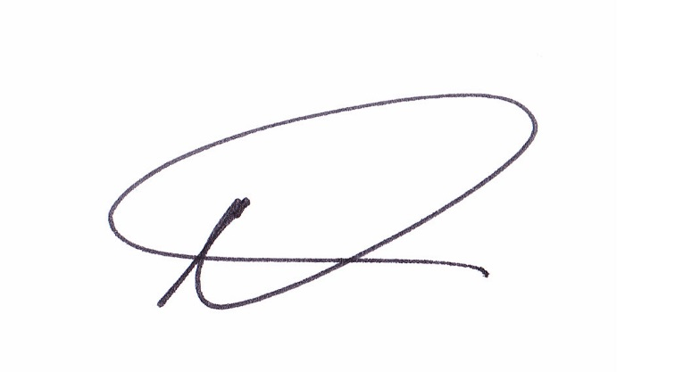

M.V.Calladine